ITA0608 - Machine Learning
Lab Exercises
- Find S Algorithm:

Aim: To implement and demonstrate the FIND-S algorithm for finding the most specific hypothesis that is consistent with the given positive training examples.

Algorithm:
• Read the training dataset containing attributes and target class.
• Initialize the hypothesis with the first positive training example.
• Traverse each training example.
• If the example is positive:
- Compare each attribute with the current hypothesis.
- If both values are the same, retain the value.
- Otherwise, replace the attribute value with "?" (any value).
• Ignore all negative examples.
• Display the final most specific hypothesis

Program:
import pandas as pd

data = [
['Sunny', 'Warm', 'Normal', 'Strong', 'Warm', 'Same', 'Yes'],
['Sunny', 'Warm', 'High', 'Strong', 'Warm', 'Same', 'Yes'],
['Rainy', 'Cold', 'High', 'Strong', 'Warm', 'Change', 'No'],
['Sunny', 'Warm', 'High', 'Strong', 'Cool', 'Change', 'Yes']
]

columns = ['Sky', 'AirTemp', 'Humidity', 'Wind', 'Water', 'Forecast', 'EnjoySport']

df = pd.DataFrame(data, columns=columns)

print("Training Dataset:\n")
print(df)

concepts = df.iloc[:, :-1].values
target = df.iloc[:, -1].values

hypothesis = None

for i in range(len(target)):
if target[i] == "Yes":
if hypothesis is None:
hypothesis = concepts[i].copy()
else:
for j in range(len(hypothesis)):
if hypothesis[j] != concepts[i][j]:
hypothesis[j] = '?'

print("\nFinal Most Specific Hypothesis:")
print(hypothesis)

Output:
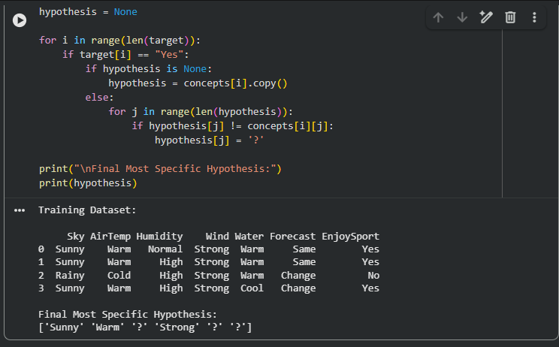

Result:
The FIND-S algorithm was successfully implemented. Based on the given positive training examples, the final most specific hypothesis obtained is:
['Sunny', 'Warm', '?', 'Strong', '?', '?']
This hypothesis represents the most specific concept that correctly classifies all positive training instances while ignoring negative examples.

